**Instructions for Portfolio Management Agent**

The model has two main parts:

1. Portfolio selection
2. Managing portfolio performance/risk over time

**Portfolio selection**

At the start you (user) will talk with an Interview Agent to describe companies you want to invest in

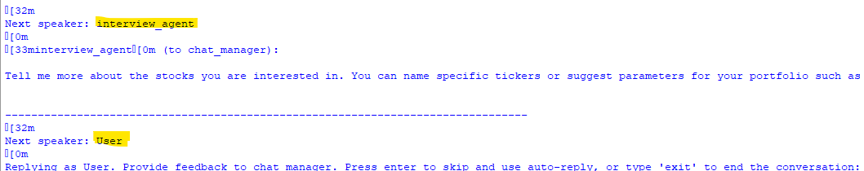

This is an essential part of the process. You should make initial suggestion and then continue conversation. As the agent instructions suggest you can suggest specific stocks or type of stocks based on their market cap, PE, beta etc.:

Tell me more about the stocks you are interested in. You can name specific tickers or suggest parameters for your portfolio such as 'Market Cap', 'PE Ratio', 'Beta', 'EPS', 'Industry', 'Sector'.

For example you can say: I am interested in technology stocks

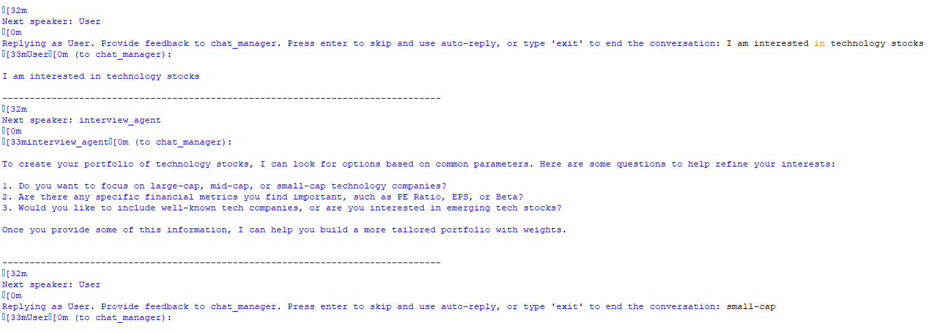

And the pick from the agent’s criteria. For example, here I said I am interested in small cap stocks and then list them by market beta. From the list I excluded Fifth Third Bancorp.

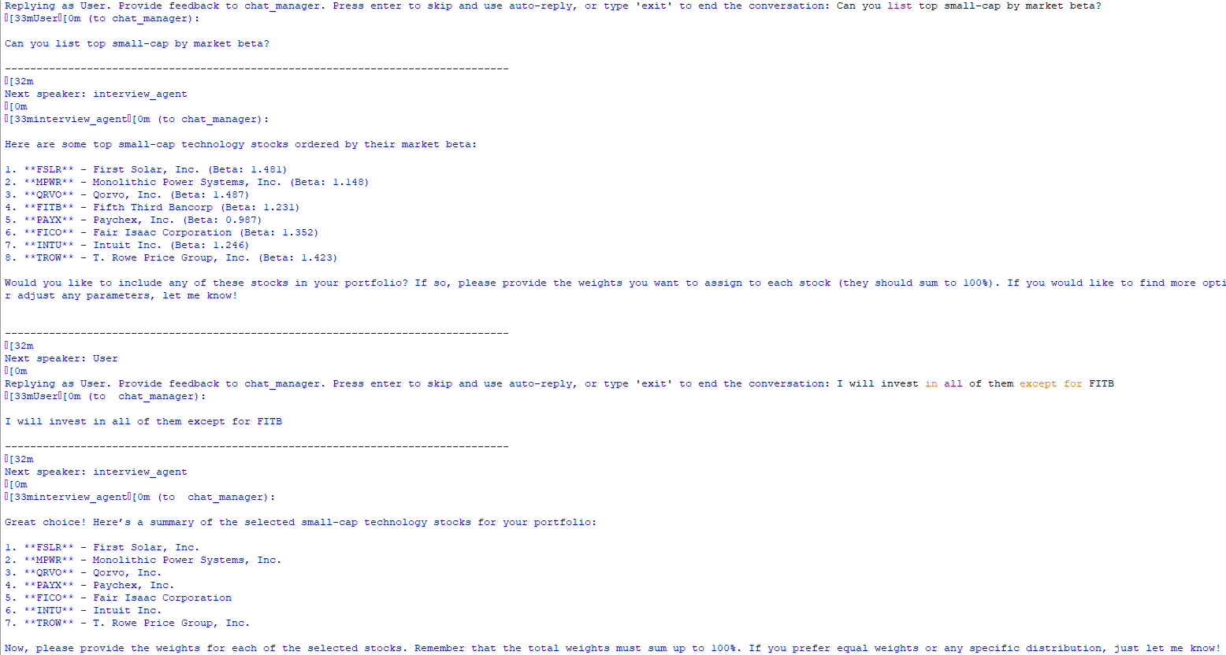

Once you narrow down the list of stocks the agent will ask you for the weights. In this example I wanted weights to reflect market cap of the selected stocks.

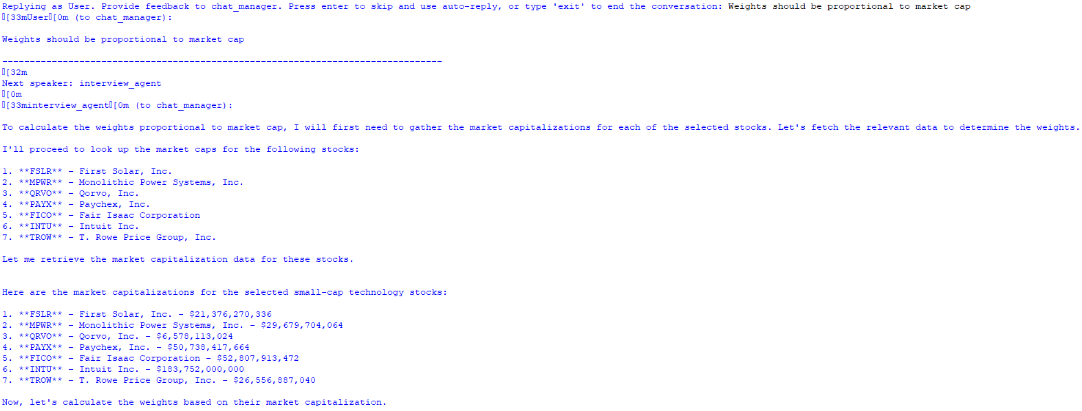

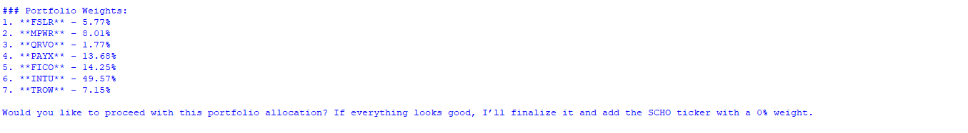

Now that the portfolio is constructed you need to approve it. As a side not to each portfolio agent will add short term money market investment with ticker SCHO. It has initial value of zero but if volatility in the market gets too high risk agent will reallocate some funds from stocks into cash.

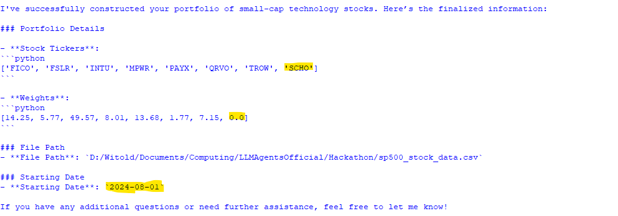

**Managing portfolio performance/risk over time**

Now that the portfolio is approved it will be invested in the market. Each day volatility of the portfolio will be calculated and compared to the target. The target volatility is set to daily standard deviation of 2% (or 32% annually) but can be adjusted as a hyperparameter.

To show how the project will work over time we need to select date from the past and them portfolio will be checked and updated daily. Here the selected date is 2024-08-01 and it will run for 5 days. It will pull actual market data for these days.

In this part there are two main agents you will be interacting with. The first one is portfolio calc agent which each computes daily risk of your portfolio based on recent market prices. The second agent is risk agent who checks if the risk is higher than 2% and reoptimizes portfolio by moving towards cash or less volatilities stocks and reducing positions in stocks that became too risky.

You have an option to first adjust portfolio weights but if you don’t provide an answer that risk agent will use default reoptimization function which is part of the Tools.

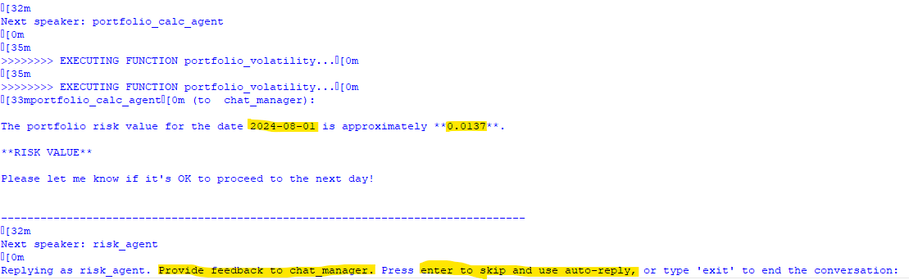

You can see in this example in the first day our portfolio volatility was 1.37%. You can say ‘NEW WEIGHTS’ and list updated weights. Or press Enter and risk agent will do his check. In this case since risk is below 2% he will OK current investment weights.